

Samuel Livingstone - B00387048

(Cover art by Blear25)

Blu Moon

Retro Games Archaeology

Games Design Document

Contents

Game Overview

3

Idea

Influences

Gameplay

4

Narrative

Gameplay

5

Aim/Goal

Mechanics

HUD

6

Aesthetic

Target Audience

Game World

7

Setting

Story

8

Game Objects

Pick-Ups

9

Characters

Audio

10

Music

Inspiration

11

Sound Effects

Game Overview

Idea:

“Blu Moon” is a 2D, single player RPG where the player is a detective who has been called to a shanty town outside the main colony on the moon of Saturn - Titan. They must solve a missing persons case and find the people responsible for their kidnapping.

Influences:

Gameplay

This game was influenced by many different stimuli. I wanted a game that had the same nostalgic sound and look as the early Gameboy Pokémon (1) games matched with the game play of Zelda (2) as well as the dialogue system of LA Noire (3).

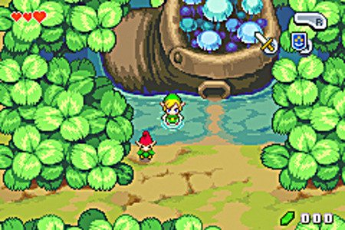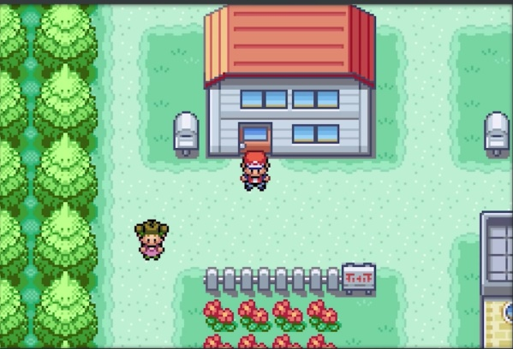

**(1)**

**(2)**

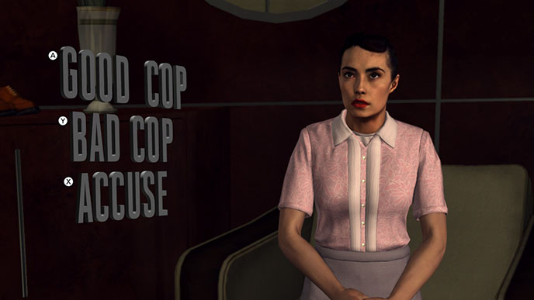

**(3)**

Narrative

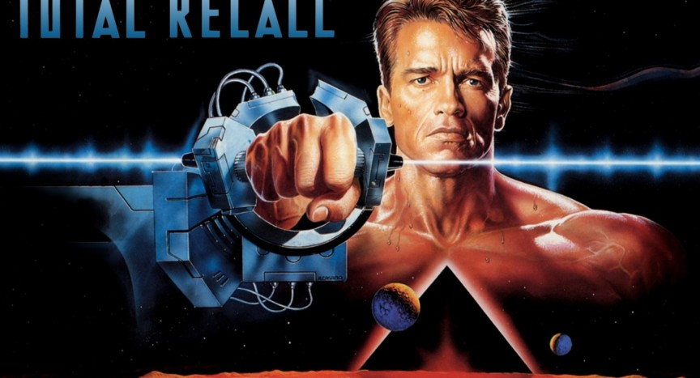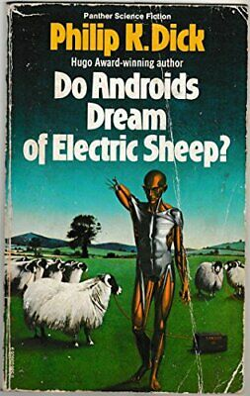With these influences I decided to make a detective/RPG. The setting of the game was inspired by science fiction movies of the 80s and 90s such as Total Recall (4), Judge Dredd (5), and others. The setting was also slightly influenced by a couple of books by Philip K. Dick such as ‘Do Androids Dream of Electric Sheep’ (6) as well as ‘Our Friends from Frolix 8’ (7)

**(4)**

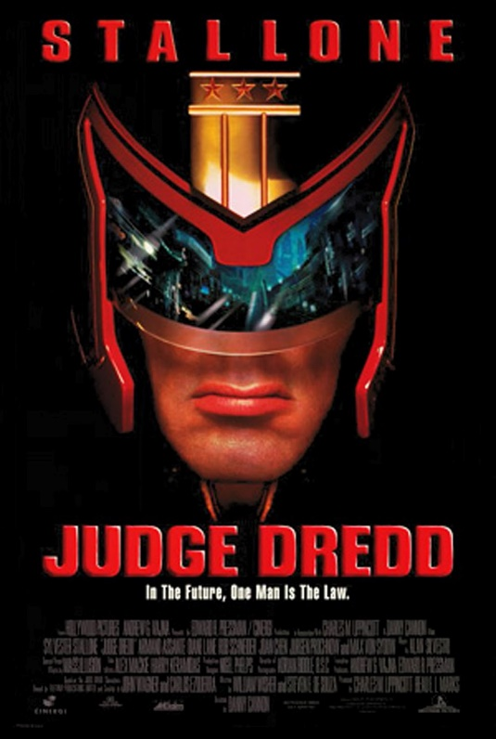

**(5)**

**(6)**

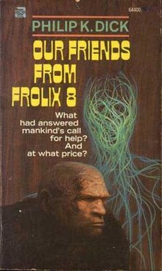

**(7)**

Gameplay

Aim/Goal

The aim of the player is to find out which in NPC is a murderer. They can do this by finding clues around the crime scene and matching them up with items around the town as well as using the dialogue system to ask questions to NPCs.

Mechanics

There will be a dialogue system implemented with a simple dialogue tree which will declare what happens through out the game for example, if the player accuses someone from the very beginning that NPC will be less likely to help them later in the game. In addition, the player will also be able to inspect clues such as footprints, notes etc

HUD

The HUD will be very minimal leaving the player to be full immersed in the environment, with the possibility of a small clues list on the screen so that the player does not have to open the menu to check them.

Aesthetic:

Utilising pixel art for the simple look in addition to make the game feel retro, with simple scenery that isn’t over whelming, using a mix of self-made assets as well as free to use ones found online.

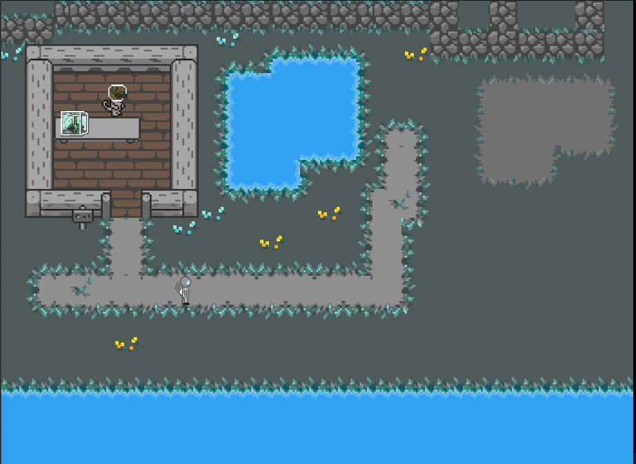

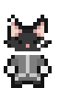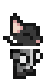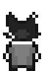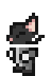

Target Audience:

The target audience for this game would be ages 12 and up as there is adult themes but they’re not prominent.

The target player would also be a fan of retro sci-fi as well as old school RPGs.

The Game World

Setting:

The game is set in 2023 on the largest moon of Saturn named Titan, where humans have started a colony to survive the incoming threat of climate change back on Earth. The main setting of the game is a small shanty town on the edge of the colony called ‘Qrull’. Qrull is a town made p of outcasts from the colony, its population is made up of sentient plants and cats, some androids also live there – some are more open about it than others.

Story:

The player is a rookie detective sent to ‘Qrull’ to solve a missing persons case to establish themself within the Poseidon Detective Agency. No one else would take the job as they didn’t care about the shunned.

Upon arrival the player is welcomed by one of the many sentient plants, this one is very polite and grateful to have help. The plant explains that one of the villagers has gone missing for days and that they are worried the worst has happened. Upon interviewing the few inhabitants, the player may have suspicions of who knows more than they let on.

The player then finds the body of the missing person with a note saying, “You don’t belong here”. This only opens more suspects as anyone could write this.

The player – using the found clues – can decide which NPC they believe did it, accuse them and arrest them. After the player has arrested their suspect, they will be told if they made the right decision. This gives the game more replay ability if they got the criminal wrong.

**Game Objects**

Pick-Ups:

The player will be able to pick up clues for example the note found with the body as well as notes found near NPCs to match handwriting etc. The player will also be able to collect clothing fragments as well as inspect footprints.

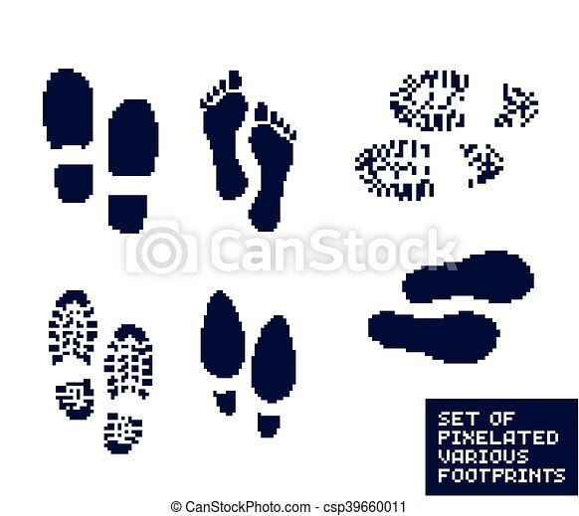

Characters:

Player

The player is a Feline Astronaut with a simple design.



NPCs

The NPCs will come in three separate designs: an Android, a sentient plant, and a cat.

The NPCs will have different roles within the game. They have professions that they attend to e.g., shop keeper, miner etc. They will all have different reactions to the player choosing certain dialogue options. Some NPCs will be red herrings to throw the player off the trail and others will try to help the player as best as they can.

**Audio**

Music

The music is inspired by the midi classics of classic Gameboy games – mainly Pokémon red & blue. The music should remind the player of the old games they used to play but without being too jarring. I found that some of the music in these games can become repetitive and annoying, so I know what to avoid when creating/finding the right music.

Inspiration:

These are some tracks used for inspiration and when they would be used within the game – Ctrl Click on the underlined words.

[Wild](https://www.youtube.com/watch?v=eBNcjvxLfFc&list=PL23DF013773415689&index=9) Battle Music – Pokémon Red and Blue – Similar but slower for interrogations to build tension.

[Overworld](https://www.youtube.com/watch?v=ncg72VswyTs&list=PL71E19E7A8803384C&index=3) Theme – The Legend of Zelda (NES) – For walking around the town, upbeat but not too happy.

[Central](https://www.youtube.com/watch?v=CoGFV_xxR64&list=PL9WcTIj-RxCGyRmn1pJgL7ch3RBl3AJYR&index=16) Park – Last Ninja 2 – The beginning of this track feels like a moment of conflict, you can imagine the beginning playing as the player finds a clue to pin someone to the murder etc.

Sound Effects:

Simple sound effects will be implemented using free assets found online. Typical sound effects would include things such as footsteps and doors opening etc.

There will also be added sound effects to evoke different feelings from the player. Such as when they find a clue or when having a discussion with an NPC.

When NPCs speak there will be sound but more like the Animal Crossing Series where when an NPCs talks it is just a noise and not someone speaking.